Unit 2: Lesson 9
Scrub-a Dub, Dub!

Goal: To learn that the physical positive actions of practicing personal hygiene and keeping your home and vehicle clean and safe help us be healthy and feel good about ourselves

Have you ever worked really hard and ended the day by taking a long, hot shower? Or washed your hair and combed it dry? Have you ever cleaned your room or car and felt so good that you washed the windows, too?

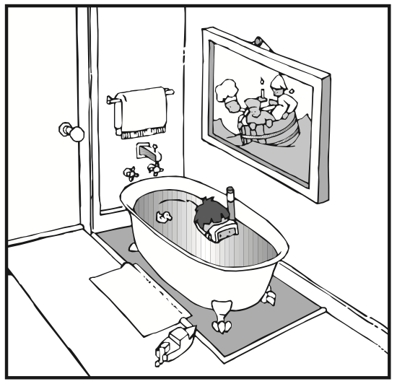

Practicing personal hygiene and keeping our home and vehicle clean and safe are positive actions that help us feel good about ourselves. It’s nice to be around people who are clean and smell nice, and it’s nice to be in places that are kept clean and safe.
Practicing Personal Hygiene. Personal hygiene is a physical positive action for keeping our bodies clean and groomed and for preventing disease. Washing our bodies, brushing our teeth, washing our hair, taking care of our fingernails, cleaning our ears, and washing our clothes are examples of personal hygiene. Our self-concepts improve when we give our bodies proper care. Other people enjoy being around us when we do.
Getting proper medical and dental care is also a physical positive action. We should have regular medical and dental checkups. These checkups are good ways to get tips for improving personal and family health, and sometimes get suggestions for home cleanliness and safety.
Keeping Our Home and Vehicle Clean and Safe. Maintaining a clean, safe home is a positive action. Our homes don’t stay clean on their own. We must deal with dust, dirt, mold, and mildew that continually invade our space. We might enter a room throwing socks and shoes, books and balls, toys and games in 10 different directions. It might seem easier to set things down where you are instead of putting them away. But the way our homes look to us affects how we feel about ourselves.
We can make household chores more interesting by doing them in different ways, by finding ways to get them done more quickly, or by making games of them. Doing the best we can and getting a chore done quickly allows us to feel good about ourselves. Did you ever hear the Mary Poppins song A Spoonful of Sugar?
Our homes should be a place where we are comforted by our surroundings. Since our actions affect others, we have a responsibility to promote safety. Keeping our things picked up off floors and stairs may prevent someone from falling. Throwing away old papers and garbage helps eliminate fire hazards. Storing dangerous items such as power tools, sharp items, firearms, and harsh chemicals in locked cabinets can help prevent tragic accidents.
Our homes need to be a haven, a place of safety and peace. Keeping our home safe means making sure we have a peaceful environment. We keep violent images and sounds out of our homes by monitoring the books, movies, TV shows, music and video games that come into our homes. We do not tolerate physical or verbal fights in our homes. We work to resolve the issues and disagreements that cause problems in our family in peaceful ways. Violence hurts – whether it comes to us or from us. And it hurts how we feel about ourselves.
Keeping a clean, safe vehicle is also a positive action. It’s easy to jump in our vehicle, drive off, and not think about keeping it clean or safe. It only takes a few minutes to drive through a car wash or to do a quick check on brake lights, headlights, taillights, turn signal, and horn. We also feel better about ourselves when we know our vehicle is clean and in safe operating condition.
Keeping ourselves, our home, and our vehicle clean and safe is so important to our self-concepts that we should give these positive actions high priority. We become the best we can be and give our best to others when we keep our bodies, our home, and our vehicle clean and safe.

QUESTIONS:
- Why is practicing personal hygiene important to our self-concepts?
- How is it important to our health?
- How do our personal hygiene practices affect others?
- What are some ways we can keep our home clean?
- What can we do to make our home safer?
- Why should dangerous objects and chemicals be locked up?
- Why does the way our home and vehicle look to us affect our self-concepts?
- How do you feel about yourself when you practice personal hygiene? When you don’t?
- What personal hygiene Positive Action could you do to improve how you feel about yourself?
- How does the way you feel about yourself affect how you care for our home?
- In what ways could you make your space or room cleaner and safer?

Now that you have discussed these topics, what practices could you do with more regularity? Now decide which positive actions you could do to make our home and vehicle cleaner and safer. Make a plan and do it!

FAMILY POSITIVE ACTIONS:
QUESTIONS:
- How does our family’s practice of personal hygiene affect the way we feel about ourselves?
- How does the way we keep our home make us feel about ourselves?
- What can we do to help one another keep our home clean and make it safe for everyone?
- How can we keep our vehicle clean and safe?

Let’s make a plan! As a family, let’s practice the positive action of personal hygiene by being considerate of one another’s needs. When we notice that supplies such as soap, shampoo, and toothpaste are nearly gone, let’s write those items on the shopping list.
Now let’s discuss ways to keep our home cleaner by identifying the chores that no one likes to do such as taking out the garbage or cleaning the bathroom. If we all pitch in and work together, we can get them done. We can make a game out of chores or set a timer to see how fast we can do them.
We could make a chore chart so everyone will know what needs to be done or whose turn it is to do a certain job. Everyone can be responsible for cleanliness!
parent positive actions
Ask Yourself: Do you allow enough time for your own personal hygiene? When were your last medical and dental checkups? What about your children’s checkups? Do you keep your home and vehicles clean and safe? Is there something more you should do? Do your children act differently when your home is clean as opposed to when it is messy?

Plan and Do: Look at yourself and your special area of your home as if you were another person seeing the for the first time. Notice what stands out in your mind. Write down the changes you would like to make. Circle the things you want to change first. Think about what it would take to make each change. Set up a schedule, and start making your changes this week.
COMMUNITY POSITIVE ACTIONS
Let’s discuss what we can do to keep our neighborhood clean and safe. We can make a special effort to clean up litter and encourage our neighbors to do the same. We might even want to organize a Clean and Safe Neighborhood Day.
Is there anything we can do to curb violence in our neighborhood?
Is there a program that children can get involved in that promotes a safe environment? Check with your Guidance Counselor to see what services are available.

SUMMARY:
Washing our bodies, brushing our teeth, and washing our hair are some positive actions we take for personal hygiene. There’s something about being clean and well-groomed that makes us feel good about ourselves. Even tiny children know when they are sweet-smelling and clean. We improve our self-concepts when we take good care of ourselves.
We also feel better about ourselves when our home and vehicle are clean and safe. We reduce disease and lessen the possibility of accidents for our family members and guests. Our community becomes a better place to live through our efforts to create clean and safe neighborhoods. Practicing personal hygiene for ourselves and keeping our home and vehicle clean and safe help us feel good about who we are and what we are doing.

Word of the Week: Creative
To be able to make something new.

